**OS ASSIGNMENT- DAY 3**

Calculate the average waiting time.

1. **FCFS SCHEDULING-**

|  |  |  |
| --- | --- | --- |
| **Process Id** | **Arrival time** | **Burst time** |
| P1 | 0 | 4 |
| P2 | 2 | 6 |
| P3 | 3 | 2 |
| P4 | 6 | 1 |
| P5 | 4 | 3 |

**Id Arrival time Burst time**

P1 0 4

P2 2 6

P3 3 2

P4 6 1

P5 4 3

**ARRIVAL ORDER: -**P1 , P2 , P3 , P5 , P4

**WAITING TIME:**

P1 = 0

P2 = 4 – 2 = 2

P3 = 10 – 3 = 7

P4 = 15 – 6 = 9

P5 = 12 – 4 = 8

**AVERAGE WAITING TIME: -** (0 + 2 + 7 + 9 + 8 ) / 5 = 5.2

**GNATT CHART**

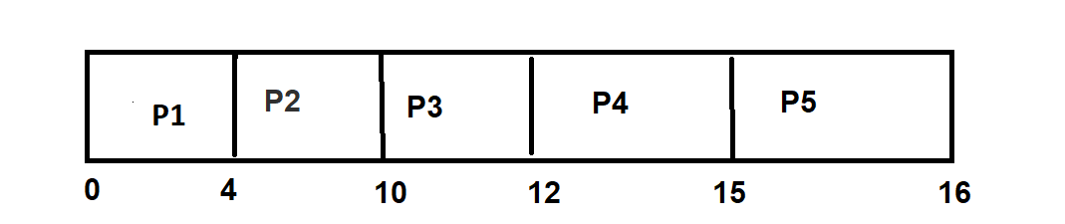

1. **SJF non-preemptive**

|  |  |  |
| --- | --- | --- |
| **Process Id** | **Arrival time** | **Burst time** |
| P1 | 0 | 6 |
| P2 | 3 | 2 |
| P3 | 4 | 4 |
| P4 | 5 | 1 |
| P5 | 2 | 3 |

**Process Id Arrival time Burst time**

P1 0 6

P2 3 2

P3 4 4

P4 5 1

P5 2 3

**ARRIVAL ORDER:** P1 , P5 , P2 , P3 , P4

**WAITING TIME:**

P1 = 0

P2 = (7 -3) = 4

P3 = (12 – 4) = 8

P4 = (6 – 5) = 1

P5 = (9 – 2) = 7

**AVERAGE WAITING TIME:** (0 + 4 + 8 + 1 + 7 ) / 5 = 4

**GNATT CHART**

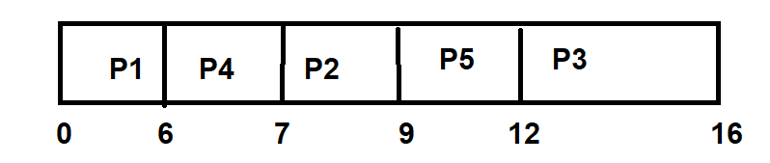

**3) SJF preemptive -SRTF**

|  |  |  |
| --- | --- | --- |
| **Process Id** | **Arrival time** | **Burst time** |
| P1 | 4 | 6 |
| P2 | 3 | 5 |
| P3 | 2 | 4 |
| P4 | 1 | 3 |
| P5 | 0 | 2 |

**Process Id Arrival time Burst time**

P1 4 6

P2 3 5

P3 2 4

P4 1 3

P5 0 2

**ARRIVAL ORDER:**

P5 , P4 , P3 , P2 , P1

**WAITING TIME:**

P1 = 14 – 4 = 10

P2 = 9 – 3 = 6

P3 = 5 – 2 = 3

P4 = 2 – 1 = 1

P5 = 0

**AVERAGE WAITING TIME:** (10 + 6 + 3 + 1 + 0 ) / 5 = 4

**GNATT CHART**

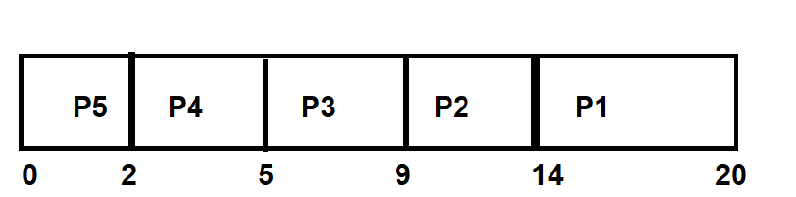

**4) Round Robin**

**Q=3**

|  |  |  |
| --- | --- | --- |
| **Process Id** | **Arrival time** | **Burst time** |
| P1 | 0 | 9 |
| P2 | 1 | 4 |
| P3 | 2 | 3 |

**Q=3**

**Process Id Arrival time Burst time**

P1 0 9

P2 1 4

P3 2 3

**ARRIVAL ORDER:**

P1 , P2 , P3

**WAITING TIME:**

P1 = (13 – 6 – 0) = 7

P2 = (12 – 3 – 1) = 8

P3 = (6 – 2) = 4

**AVERAGE WAITING TIME:**

( 7 + 8 + 4 ) / 3 = 6.33

**GNATT CHART**

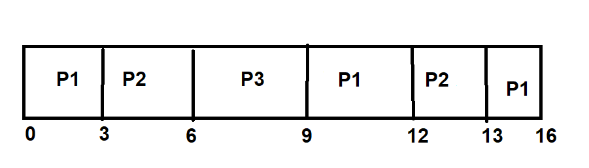

**Q = 5**

|  |  |  |
| --- | --- | --- |
| **Process Id** | **Arrival time** | **Burst time** |
| P1 | 0 | 10 |
| P2 | 5 | 20 |
| P3 | 10 | 15 |
| P4 | 15 | 5 |

**Process Id Arrival time Burst time**

P1 0 10

P2 5 20

P3 10 15

P4 15 5

**ARRIVAL ORDER:**

P1 , P2 , P3 , P4

**WAITING TIME:**

P1 = (10 – 5 – 0) = 5

P2 = (45 – 15 – 5) = 25

P3 = (40 – 10 - 10) = 20

P4 = 25 – 15 = 10

**AVERAGE WAITING TIME:**

( 5 + 25 + 20 + 10 ) / 4 = 15

**GNATT CHART**

